**Create HTTP Requests To Communicate With Mobile Application**

Team

Id

P

NT2022TMID41953

Project

Hazardous Area Monitoring

for

Industrial

Plant

using

IoT

**Node**

**red**

**flow**

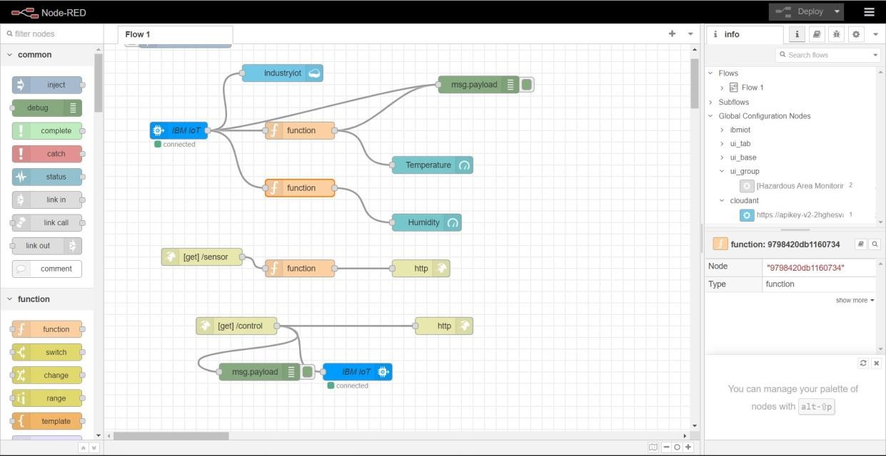

**Http**

**requests**

